**Unit 8: We’re off!**

**LESSON GOALS**

|  |  |
| --- | --- |
| **Vocabulary** | + Phát âm, hiểu nghĩa, viết đúng chính tả các từ thuộc chủ đề “***Transport***” và “***Travel***”  + Sử dụng được các từ/ cụm từ này áp dụng vào các bài tập và các kĩ năng: Nghe, Nói, Đọc & Viết của bài 8  + Phân biệt và sử dụng được các giới từ thường dùng với ***Transport*** & ***Travel*** |
| **Grammar** | + Nhận biết cấu trúc và cách sử dụng ***câu điều kiện loại 1 & 2***  + Phân biệt được ***câu điều kiện loại 1 & 2*** |
| **Listening** | + Nghe và xác định thông tin chi tiết, thông tin đúng sai  + Luyện tập dạng bài Part 3 – PET |
| **Reading** | + Đọc và tìm thông tin chi tiết  + Đọc và xác định thông tin đúng sai (Part 3–PET) |
| **Speaking** | + Tả tranh, luyện tập hội thoại thể hiện ý kiến, sở thích về địa điểm và hoạt động du lịch, hỏi và trả lời sử dụng câu điều kiện loại 1 & 2 |
| **Writing** | + Hoàn thành đoạn văn ngắn và email sử dụng thì Quá khứ đơn và Quá khứ tiếp diễn  + Luyện tập viết email chủ đề kỳ nghỉ (Part 2 – PET) |

**PRACTICE**

**A. VOCABULARY: Transport & Travel**

**Exercise 1: Write the letters in boxes to complete the means of transport vocabulary.**

|  |  |  |  |
| --- | --- | --- | --- |
| **1. t _ _ i _** | **2. _ l _ _ e** | **3. cr _ _ se ship** | **4. ba _ _ oo _** |
| **5. s _ _ p** | **6. h _ l _c _ pt _ r** | **7. b _ _ t** | **8. sc _ _t _ r** |
| 9. f _ rr _ | 10. s _ bm _ r _ ne | 11. school b_ s | 12. v _ n |

62

**Exercise 2: Match the word with the pronunciation and meaning.**

|  |  |  |  |  |
| --- | --- | --- | --- | --- |
| **No.** | **Words/phrases** | **Pronunciation** | **Meaning** | **Answer** |
| **1** | hot air balloon | a. /ˈplætfɔːm/ | *A. tắc đường* | *1. i-C* |
| **2** | cruise | b. /kruːz/ | *B. đi du lịch bằng tàu biển, đi tàu biển* |  |
| **3** | departure | c. /ˈsiːsɪk/ | *C. khinh khí cầu* |  |
| **4** | flight attendant | d. /ˈsiːt ˌbelt/ | *D. rời đi, ga đi* |  |
| **5** | harbour | e. /ˌsʌbməˈriːn/ | *E. tiếp viên hàng không* |  |
| **6** | helicopter | f. /ˈflaɪt əˌtendənt/ | *F. cửa lên tàu* |  |
| **7** | luggage | g. /ˈspiːd ˌlɪmɪt/ | *G. tàu ngầm* |  |
| **8** | platform | h. /dɪˈpɑːrtʃɚ/ | *H. hành lý* |  |
| **9** | roundabout | i. /hɒtˈeə bəˌluːn/ | *I. bến cảng* |  |
| **10** | seasick | j. /ˈhɑːrbɚ/ | *J. vòng xuyến* |  |
| **11** | seat belt | k. /ˈtræfɪk ˌdʒæm/ | *K. say sóng* |  |
| **12** | speed limit | l. /ˈhelɪˌkɒptɚ/ | *L. đai an toàn* |  |
| **13** | submarine | m. /ˈlʌɡɪdʒ/ | *M. giới hạn tốc độ* |  |
| **14** | traffic jam | n. /ˈraʊndəbaʊt/ | *N. trực thăng* |  |

**Exercise 3: Underline the odd one out in each set.**

|  |  |  |  |  |
| --- | --- | --- | --- | --- |
| 1. | airport | harbour | station | platform |
| 2. | ride | fly | land | take off |
| 3. | check in | weigh | board | wave |
| 4. | seasick | lovesick | carsick | airsick |
| 5. | boarding card | departure gate | hand luggage | crowded |
| 6. | flight attendant | seat belt | security guard | pilot |
| 7. | motorway | roundabout | speed limit | traffic lights |
| 8. | traffic jam | catch | get on | get off |

**Exercise 4: Vocabulary quiz.**

1. A person whose job is to serve and take care of passengers on a plane.

a. pilot b. astronaut c. flight attendant

2. The flat area at a train station where you get on or off the train.

a. platform b. harbour c. bus stop

3. A journey by sea, visiting different places, especially as a holiday.

a. cruise b. vacation c. coast

63

4. A long line of vehicles on a road that cannot move or can only move very slowly.

a. traffic lights b. traffic jam c. traffic soup

5. A place where roads meet forming a circle, that all traffic must go around in the same direction.

a. roundabout b. motorway c. runway

6. A comfortable bus for carrying passengers over long distances.

a. van b. coach c. school bus

7. A vehicle, usually smaller than a lorry, used for carrying goods or people.

a. truck b. train c. van

8. A stamp or mark put in your passport by officials of a foreign country, which permit you to enter their country.

a. ticket b. luggage c. visa

**Exercise 5: Choose a proper preposition.**

1. To avoid pollution we should go ***by/ off/ on*** bicycle more.

2. Going ***by/ into /on*** foot is good for your health.

3. When I got home, I got ***into/ on/ out of*** the taxi and went into the house.

4. He first met his wife ***into/ by/ on*** a ferry.

5. I walk to college but if it rains I go ***by/ in/ on*** school bus.

6. Have you ever been ***by/ off/ on*** a cruise ship?

7. He got ***off/ out of/ into*** his car and drove all the way to Leeds.

8. At the harbour, I bought a ticket and got ***by/ off/ on*** the ship to go to Paris.

9. When I rode my motorcycle ***to/ out of/ on*** Glasgow, it took 8 hours.

10. After the flight, I got ***on/ into/ off*** the plane.

11. We got ***on/ out of/ off*** the plane and sat in our seats.

12. She got ***into/ on/ off*** the train, came out of the station, and caught a taxi to go home.

**B. GRAMMAR: First & second conditional**

**Exercise 6: Put the verbs in brackets in First conditional into the correct form.**

1. If the sun (shine) ……………….., we (walk) ……………….. into town.

2. If he (have) ……………….. a temperature, he (see) ……………….. the doctor.

3. I (be) ……………….. very happy if my friends (come) ……………….. .

4. If we (travel) ……………….. to Hanoi, we (visit) ……………….. the museums.

5. You (slip) ……………….. on the rocks if you (wear) ……………….. sandals in the mountains.

64

**Exercise 7: Match an if-clause in A with a suitable main clause in B.**

|  |  |
| --- | --- |
| **A** | **B** |
| **1. If I came home earlier,** | **a. they would play in our football team.** |
| 2. If Tung and Thanh were older, | b. you would earn some extra money. |
| 3. If Xuan studied harder, | c. I could prepare the dinner. |
| 4. If you got a part-time job, | d. she would be better at school. |
| 5. If I had time, | e. I would go shopping with you. |

**Exercise 8: Put the verbs in brackets into the correct form. The sentences can be either First or Second conditional.**

1. If Giang (forget) ……….…………… her homework, the teacher will give her a low mark.

2. My boyfriend could visit us if we (live) ……….…………… in Ho Chi Minh city.

3. If they go to the disco, they (listen) ……….…………… to loud music.

4. I would invite Thomas to my birthday party if he (be) ……….…………… my friend.

5. I (ask) ……….…………… my parents if you wait a minute.

6. They would buy a car if they (have) ……….…………… enough money.

7. We would go on a cruise if we (win) ……….…………… the lottery.

8. We will save thousands of trees if we (not waste) ……….…………… paper.

9. If you want a refund, you (have to) ……….…………… show your receipt.

10. I (help) ……….…………… you carrry the piano if I were stronger.

Exercise 9: Write a Second conditional sentence for each situation, as in the example.

1. People throw rubbish in the streets. The streets don’t look nice.

*🡪 If people didn’t throw rubbish in the streets, they would look nice.*

2. There are so many billboards in our city. People cannot enjoy the view.

🡪 _______________________________________________________________________________

3. There is so much light in the city at night. We cannot see the stars clearly.

🡪 _______________________________________________________________________________

4. We turn on the heater all the time in winter. We have to pay 3 million dong for electricity a month.

🡪 _______________________________________________________________________________

5. The karaoke bar makes so much noise almost every night. The residents complain to its owner.

🡪 _______________________________________________________________________________

6. She has a headache after work everyday. She works in a noisy office.

🡪 _______________________________________________________________________________

7. Janet can’t get the job because she doesn’t have a certificate.

🡪 _______________________________________________________________________________

65

8. He has behaved very badly so everyone doesn’t want to talk to him.

🡪 _______________________________________________________________________________

9. John is fat because he eats a lot of chips.

🡪 _______________________________________________________________________________

10. We can’t drive to work because the weather is too bad this week.

🡪 _______________________________________________________________________________

Exercise 10: Rewrite the sentence so that it means the same as the first one.

1. If she doesn’t go to bed early, she will be tired in the morning.

Unless …………………………………………………………………………………………………

2. If you don’t have an invitation, you cannot get into this party.

Unless …………………………………………………………………………………………………

3. We will arrive on time if we hurry.

Unless …………………………………………………………………………………………………

4. If you don’t practise the piano everyday, you won’t improve.

Unless …………………………………………………………………………………………………

5. If he doesn’t get on well with his neighbors, they won’t help him.

Unless …………………………………………………………………………………………………

6. If he phones me, he will get some information about her.

Unless …………………………………………………………………………………………………

7. Unless you save some money, you will never be able to go on a vacation.

If ………………………………………………………………………………………………………..

8. We will miss the bus unless we run quickly.

If ………………………………………………………………………………………………………..

9. You will feel cold unless you wear a warm coat.

If ………………………………………………………………………………………………………..

10. Unless he studies hard for his exam, he will fail.

If ……………………………………………………………………………………………………….

66

**C. READING:**

**Exercise 11: Read the emails below.**

|  |
| --- |
| Dear Mum and Dad,  I'm a bit worried. Mia couldn't sleep at all last night because her arm hurt. And a giant mosquito bit me on the leg and now it's enormous (my leg, not the mosquito). This guesthouse is hot and dirty and horrible. Anyway, I had a text from Erwin this morning, so that was good!  Love, Emily |
| **Email A** |
| Hi!  We all had a great day together today. We hired motorbikes and rode to some fantastic beaches. They're just small bikes, Mum. Mia fell off once and cut her arm, but Daan put a plaster on it and it's OK now. We bought food in a village and had a picnic by the sea - delicious chicken and rice and fruit - and it cost almost nothing!  XXX Emily |
| **Email B** |
| Hello again!  We're all at the guesthouse. It's OK, but not very clean and there's no air-conditioning. I found an enormous spider in my room and Erwin killed it for me. He's really sweet! We spent the whole day together. We just sat on the beach and talked and talked. Don’t worry, Mum!  Bye! Emily |
| **Email C** |
| Hi!  Mia and I got here about two hours ago, so I'm just writing to say we're OK, but very tired after the long flight. We met two Dutch boys (Erwin and Daan), who told us about a great guesthouse. It's very cheap and right on the beach. They're staying there already. We're going there with them now to get a room for Mia and me.  More later, Emily |
| **Email D** |
| Dear Mum and Dad,  We need your help. This morning Mia went to a clinic and I went to a pharmacy. We spent lots of money. The good news is that we're both OK now! Yesterday we moved to a hotel. It's really cool and clean, but it's quite expensive. Can you send us some money quickly, please?  Love you and miss you lots and lots, Emily |
| **Email E** |
| Hello Mum and Dad,  We're very sad today because our Dutch friends left last night. I gave them our address because they're going to England later this year, and I said they could stay at our house. That's all right, isn't it? I know you'll like them!  Love, Emily |
| **Email F** |
| 67 |



***Part 1****:* ***Lots of young people take a long break after they leave school or university and go travelling. Read the emails above which Emily, a girl who is having a gap year, wrote to her parents. As you read, answer these questions:***

1. Who is Emily travelling with?

______________________________________________________________________________

2. Where do Daan and Erwin come from?

______________________________________________________________________________

3. Why did Emily give them her address?

______________________________________________________________________________

***Part 2: Now match the emails with the pictures to put them in the order that Emily sent them. The first one is given as an example.***

|  |  |  |  |  |  |
| --- | --- | --- | --- | --- | --- |
| **1** |  | **2** |  | **3** |  |
| **4** |  | **5** |  | **6** |  |

1…**D**… 2 ……… 3 ……… 4 ……… 5 ……… 6 ………

68

***Part 3: Decide if the statements below are True (T) or false (F).***

1. __________ Mia and Emily met some good friends.

2. __________ They hired a taxi to the beaches.

3. __________ The guest house is equipped with a modern air-conditioner.

4. __________ Emily found a huge spider.

5. __________ Mia and Emily didn’t feel happy when the boys went home.

6. __________ The trip that Emily and Mia took was not costly.

7. __________ Emily and Mia had so little money that they had to ask their parents to send them some.

8. __________ Their Dutch friends could visit their house in England soon.

**D. LISTENING:**

**Exercise 12:**

**Part 1: Listen to two conversations between Helen and Steve, and Nick and Tricia. Complete each sentence with the name of the appropriate person.**

|  |  |
| --- | --- |
| **Conversation 1: *Helen and Steve*** | **Conversation 2: *Nick and Tricia*** |
| 0. … ***Helen*** … went to France.  1. ……………… had hot weather.  2. ……………… stayed at a campsite near the sea.  3. ……………… didn’t go away, but stayed at home.  4. ……………… went on some trips with their friends. | 5. ……………… didn’t go abroad for their holiday this year.  6. ……………… had a very good guide.  7. ……………… relaxed and read a lot of books. |

**Part 2: Listen again and make notes to complete the table. Write no more than 3 words.**

|  |  |  |
| --- | --- | --- |
| **Name** | **Where did they go?** | **What did they do?** |
| ***Helen*** | (1) ………………………………………………….…………… | (2) ………………………………………………….…………… |
| ***Steve*** | (3) ………………………………………………….…………… | (4) ……………………………… on the house  (5) ……………………………… some trips |
| ***Nick*** | (6) ………………………………………………….…………… | (7) ……………………………… holiday |
| ***Tricia*** | (8) ………………………………………………….…………… | (9) ……………………………… time and  (10) ……………………………… of books |

69

**Exercise 13:**

**Part 1: Four hotel guests are calling for a taxi. Listen and decide if the statements true or false?**

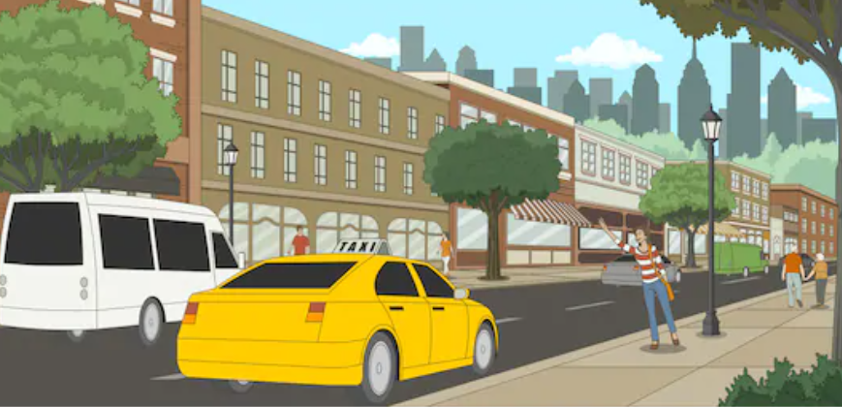

|  |  |  |  |
| --- | --- | --- | --- |
| **Conversation** | | **True** | **False** |
| **1** | a. The caller is at 420 Evergreen Street. |  | Checkmark |
|  | b.The caller’s flight leaves in four hours. |  |  |
| **2** | a. The caller wants to go to another hotel. |  |  |
|  | b.The taxi number is 3556. |  |  |
| **3** | a. The caller is at 817 Iowa Avenue. |  |  |
|  | b.The caller needs to catch a train. |  |  |
| **4** | a. The caller’s friend is going to have a baby soon. |  |  |
|  | b.The taxi number is 5393. |  |  |

**Part 2: Listen again. How much will each ride cost? Circle the correct answer.**

1. a. $14 b. $40

2. a. $12 b. $20

3. a. $15 b. $50

4. a. $18 b. $80

**E. WRITING:**

**Exercise 14: Read the stories of unlucky travelers. Write the correct form of the words to complete the sentences using Past simple and Past continuous.**

1. Last month, I (put) ………………….. off booking my holiday for a few weeks because I (be)

………………….. unsure of my plans. When I finally (book) ………………….., they (set) ………………….. all the prices up!

2. I (travel) ………………….. to Edinburgh by train last year. When the train (arrive) ………………….. at the platform, unfortunately, I (sleep) ………………….. . When I finally (wake) ………………….. up, nine hours later, I (be) ………………….. in Aberdeen – 200 km further north!

70

3. A few weeks ago, when I (drive) ………………….. to Manchester to meet some old friends for

lunch, I (get) ………………….. stuck in traffic for five hours. I (miss) ………………….. the lunch but luckily, I still (see) ………………….. my friends.

**Exercise 15: Use some of the verbs from the box to complete this postcard. You need to put them in the correct Past Simple form.**

|  |
| --- |
| ***visit climb drive go arrive***  ***listen buy relax eat enjoy*** |

Hi! Yesterday we (1) ………………….. into the mountains and visited a beautiful medieval town, so today we (2) ………………….. by the pool. This morning I walked to a market and (3) ………………….. bread and fruit for lunch. We (4) ………………….. warm sunny weather and (5) ……………….. lots of delicious Spanish food.

Wish you were here!

**Exercise 16: Write an email to your English friend, Neil, about one of your unforgettable trips. Write your email in about 70-80 words. In your email, you should tell him:**

* *where you went*
* *what you did*
* *what made it unforgettable to you.*

………………………………………………………………………………………………………………………………………………………

………………………………………………………………………………………………………………………………………………………

………………………………………………………………………………………………………………………………………………………

………………………………………………………………………………………………………………………………………………………

………………………………………………………………………………………………………………………………………………………

………………………………………………………………………………………………………………………………………………………

………………………………………………………………………………………………………………………………………………………

………………………………………………………………………………………………………………………………………………………

………………………………………………………………………………………………………………………………………………………

* *2.*

71

**F. SPEAKING:**

**Exercise 17: Work in pairs to ask and answer questions in First & Second conditionals.**

1. If you had one wish, what would it be?

_________________________________________________________________________________

2. What would you do if you won a million dollar?

_________________________________________________________________________________

3. Where will you go if you have some free time this weekend?

_________________________________________________________________________________

4. What will you do if you go on a holiday but it rains all the time?

_________________________________________________________________________________

5. What would you do if you went on a picnic and got lost in a forest?

_________________________________________________________________________________

**Exercise 18: Describe the pictures about holidays.**

|  |  |
| --- | --- |
| **Part 1. Describe the pictures about holidays.**  ***You should say:***  - Where the people are  - What they are doing | **Part 2. Discussion**  - Which activity do you prefer? Why?  - Which activities would you like to try/which place would you like to go if you had opportunity and why? |

|  |  |
| --- | --- |
| **1** | **2** |
| **3** | **4** |

**Exercise 19: Work in pairs. Use the dice to play the board game by answering the questions about holidays.**

73

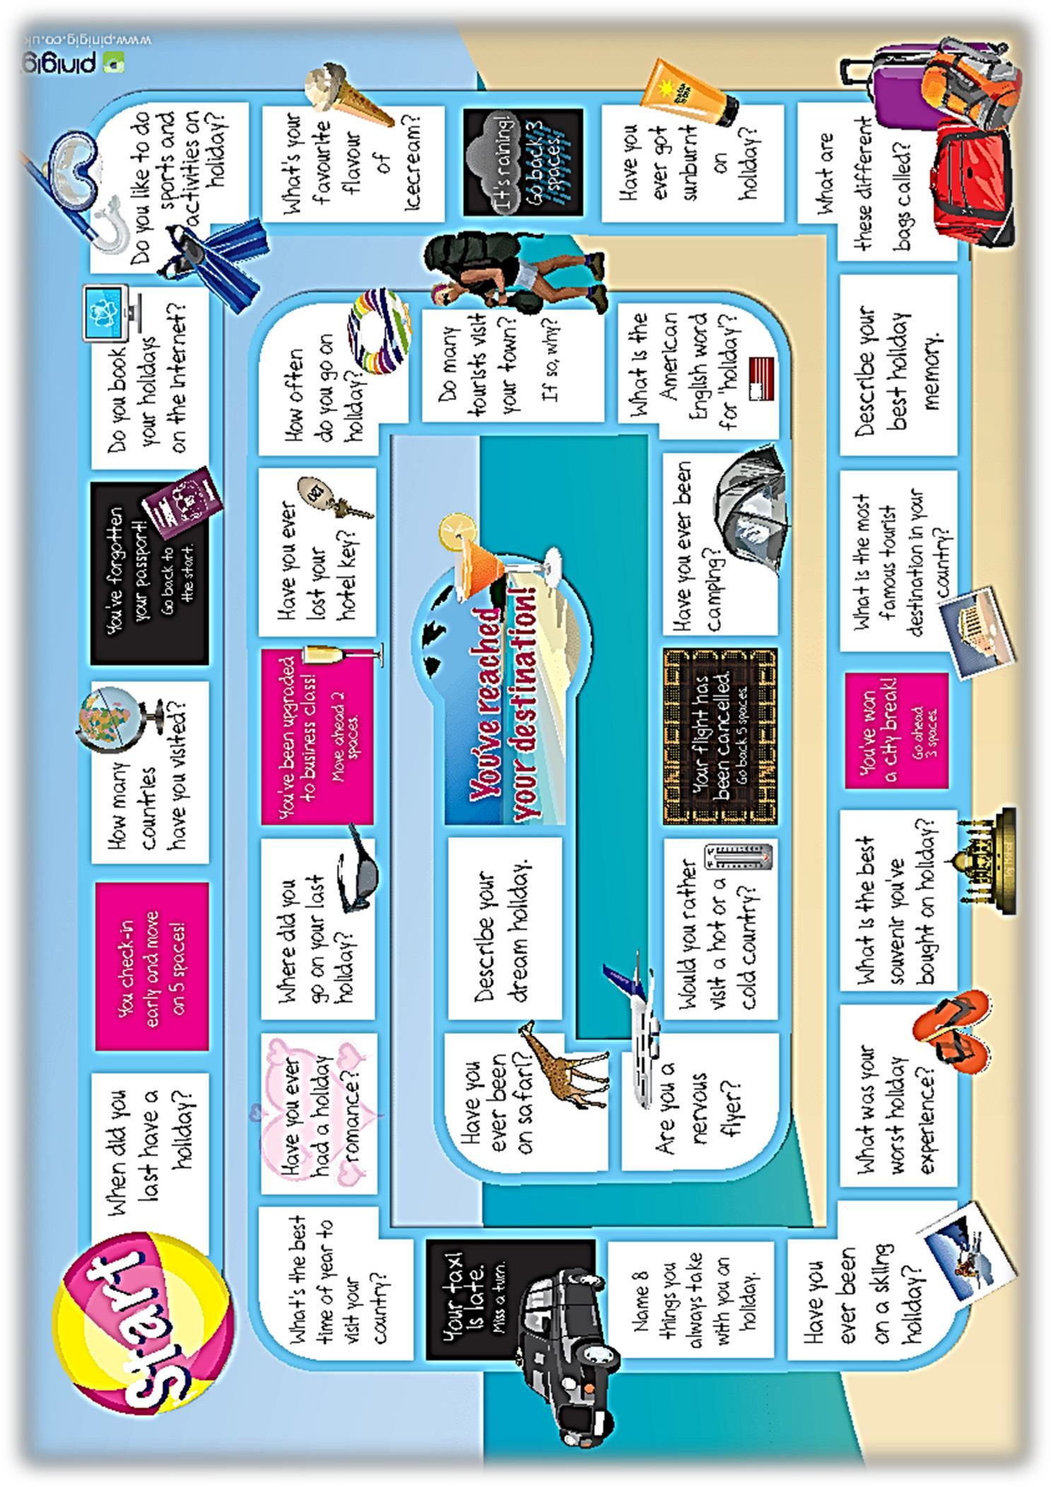

74